Product description
SWISSPACER AIR for permanent pressure equalisation in multi-pane insulating glass units
- Metal sleeve with integrated special membrane, developed as a solution for permanent pressure equalisation, in order to transport the multi-pane insulating glass unit over differences in height and to minimize the distortions of the glass panes due to the climatic loads.

Performance description
Can be used in multi-pane insulating glass units in accordance with DIN EN 1279
- The metal sleeve is installed in the edge seal of a multi-pane insulating glass unit and enables pressure equalisation between the surrounding environment and the space between the panes.
- When determining the properties and dimensions of the multi-pane insulating glass unit, air must be assumed, as any other kind of filling gas would quickly volatilise.
- The special structure prevents water vapour from being able to accumulate in the space between the panes, which would otherwise lead to the formation of condensation or damage the metallic Low-E-coatings.
How SWISSPACER AIR works during transport over differences in height
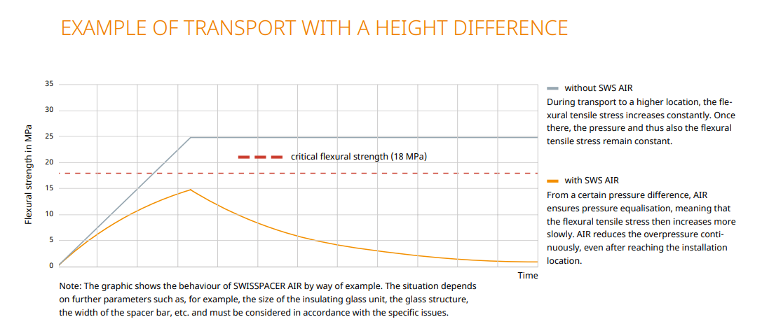
© SWISSPACER
SWISSPACER AIR is approved by DIBt (Deutsches Institut für Bautechnik)
- General building inspection approval / Technical approval (DIBt) No. Z-70.4-249 of 11 March 2019 for: Pressure-equalised multi-layer insulated glazing with Swisspacer Air pressure equalisation valve (English translation of the German original)

Complementary product
Warm edge spacer SWISSPACER Advance
- Polymer SAN spacer with 35% glass fibre content and thermally improved aluminium foil
- Equivalent thermal conductivity (in accordance with ift guideline WA-17/1): λ = 0.29 W/mK
- Available in a total of RAL-like colours
RAL 9023, 9005, 9016, 5003, 8003, 8014, 1016, 6018, 6026, 7013, 1011, 1034, 6010, 1015, 1001, 7035 or 8012

Complementary premium product
Warm edge spacer SWISSPACER Ultimate
- Polymer SAN spacer with 35% glass fibre content and high-tech gas barrier foil
- Equivalent thermal conductivity (in accordance with ift guideline WA-17/1): λ = 0.14 W/mK
- Available in a total of 17 RAL-like colours
RAL: 9023, 9005, 9016, 5003, 8003, 8014, 1016, 6018, 6026, 7013, 1011, 1034, 6010, 1015, 1001, 7035 or 8012

Manufacturer
SWISSPACER Vetrotech Saint-Gobain International AG
Sonnenwiesenstrasse 15 | 8280 Kreuzlingen, Switzerland
www.swisspacer.com; info@swisspacer.com

